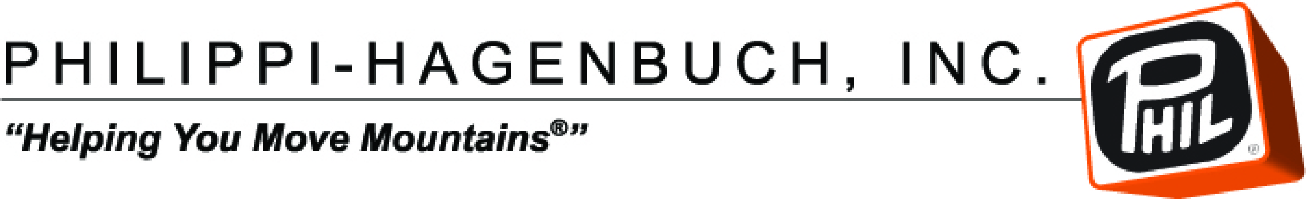  FOR IMMEDIATE RELEASE | Contacts:  Josh Swank  309-634-0026  jjswank@philsystems.com  Philippi-Hagenbuch  Rachel Stanislawski  701-373-0062  rachel.s@ironcladmktg.com  IRONCLAD Marketing

Philippi-Hagenbuch Inducted Into SSAB Hardox In My Body Program at MINExpo 2016

LAS VEGAS (Sept. 26, 2016) – Philippi-Hagenbuch, Inc. is honored to announce their acceptance into SSAB’s “Hardox In My Body” program, an exclusive program for OEM’s that use Hardox steel exclusively throughout their equipment. The induction ceremony took place at Philippi-Hagenbuch’s booth at MINExpo 2016.

Admittance into the Hardox In My Body program verifies that Philippi-Hagenbuch’s HiVol® bodies have been manufactured using Hardox steel and not an inferior imitation. It means that PHIL’s truck bodies, water tanks and trailers represent first-class products that deliver unsurpassed wear resistance and impact strength, saving time, weight and money for their clients down the road while increasing the products useful life.

Philippi-Hagenbuch has been using SSAB’s Hardox steel to construct their mining-class HiVol truck bodies since the 1980’s and helped to pioneer Hardox’s introduction to the mining market within the America’s at that time. PHIL uses Hardox differently than the competition; if they use Hardox, it’s solely used within the load containing area for its wear resistance properties. PHIL on the other hand utilizes the Hardox steel in every aspect of its truck bodies.

“We don’t believe in taking shortcuts; we’re not a Me-Too company; we constantly innovate to keep our designs and technology cutting edge, and using Hardox throughout our design is a part of our formula” stated Josh Swank, vice president of sales and marketing for Philippi-Hagenbuch.

PHIL further broadened its use of the Hardox material in the 1990’s in their extensive line of off-highway trailers, and in 2001 PHIL began using Hardox exclusively to construct their water tanks.

To become a member of the Hardox In My Body program, Philippi-Hagenbuch underwent an extensive assessment, vetting that all PHIL HiVol truck bodies are manufactured to the highest standards available. Eligibility in this program is maintained through stringent professional criteria set by SSAB. PHIL chose to join the Hardox In My body program as a way of authenticating the trust their customers place in them; this program is an additional guarantee of the quality of material that’s used to build their equipment.

SSAB honored Philippi-Hagenbuch further by utilizing images of PHIL HiVol HardRock® Bodies within their MINExpo 2016 marketing campaign and booth design. Their new campaign designed for this year’s show has the themes of: “I’m Hard And Tough” and “Some Call Me The Beast”.

About Philippi-Hagenbuch Inc.

Located in Peoria, Illinois, Philippi-Hagenbuch Inc. has been building equipment for off-highway haul trucks since 1969, and has become the global leader in off-highway truck customization. In addition to rear-eject bodies and trailers, Philippi-Hagenbuch designs and builds end-dump bodies, trailers, tailgates and water tanks for nearly every make and model of articulated and rigid frame off-highway truck available. For more information, contact Philippi-Hagenbuch, 7424 W. Plank Road, Peoria, IL 61604, call 309-697-9200, toll-free 800-447-6464, fax 309-697-2400, email sales@philsystems.com, visit www.philsystems.com, Facebook, Twitter, LinkedIn or YouTube.

###

IMAGE: PHIL_HiVol body.jpg

CUTLINE: Philippi-Hagenbuch’s HiVol® bodies have been manufactured using Hardox steel and not an inferior imitation.

Suggested Tags: Philippi-Hagenbuch, MINExpo2016, mine16, Hardox In My Body, HiVol® bodies

Suggested Social Media Posts:

Facebook/Twitter: @Philippi-Hagenbuch was accepted into SSAB’s “Hardox In My Body” program @minexpo. Learn more at booth 4609. #mine16 (link)

LinkedIn: Philippi-Hagenbuch was accepted into SSAB’s “Hardox In My Body” program during a ceremony at MINExpo 2016. Learn more at booth 4609. (link)

